**

**Middle East Technical University**

**Electrical - Electronics Engineering Department**

***EE493 - Engineering Design I***

***Weekly Report***

**Group Name:** λambda

**Date:** 14.11.2021 *(Week 4&5)*

**Design Coordinator:**

Associate Professor Dr. Elif Vural

**Members of Company :**

**-**Berk Erhan Yüksel

**-**Necdet Can Sönmez

**-**Mustafa Barış Emektar

**-**Alper Saraç

**-**Furkan İtkü

1. **Done During Week 4**
2. At the advice of Mrs. Vural, it was decided that a pairwise comparison schematic be drawn to determine which project the group was most favorable towards. The group discussed criteria that they deemed important to themselves. These criteria ended up to be:

* ***Ease of Mechanical Implementation (EMI):***

Mechanical systems should be uncomplicated, convenient and efficient.

* ***Fun (FUN):***

It should have a motivational and entertaining effect on the team.

* ***Contribution to Professional Development (CPD):***

It should be in a structure where team members can improve themselves and learn something new.

* ***Software Oriented (SO):***

How much importance the system attaches to the software should be evaluated.

* ***Make People’s Life Easier (MPLE):***

As a product, the project should solve the problems that people experience and make their lives easier.

* ***Compatibility of Candidates’ Competencies (CCC):***

Depending on the competencies of the team, the project should be compatible.

* ***Cost Efficiency (CE):***

The project should not be high in terms of budget and cost, it should comply with the limits.

* ***Flexibility (FLX):***

The project must be developable by the team with respect to the limits set.

1. After determining the criteria, the group voted to decide the coefficient of the importance of each criterion. To do so, each member gave a grade of either 0, 0.5, or 1 to each pair to denote which of the criteria was more important to them. After summing the grades and normalizing them, the coefficients of importance were found.
2. After finding the coefficients of importance, the group then scored each project for its suitability of given criteria. After summing the given scores, and multiplying them with the relevant coefficient of importance, the final grade of each project was found. It is presented in the table below:

***Table 1.1*** *Comparison of the Determined Criterias with Each Other*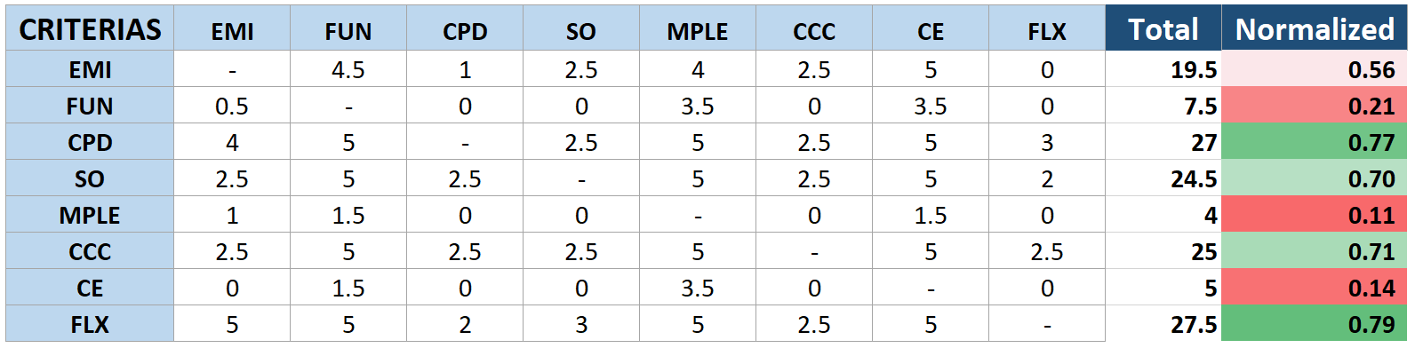

***Table 1.2*** *Project-Based Assessment Scale*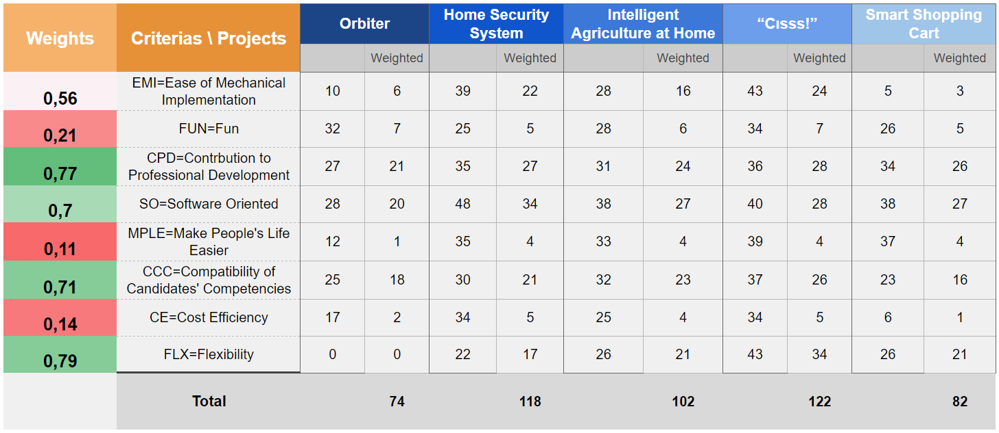

1. **Planned for Week 5**
2. According to the end result of the pairwise comparison chart, the projects must be discussed once more to determine which project the group would like to realize.
3. The project determined as a result of the scoring will be evaluated in detail.
4. A plan will be created for the work to be done in the coming weeks.